**4. Conceptual contribution**

Summary zhang

1. Print a pattern and attach it to a planar surface.

2. Take a few images of the model plane under different

orientations by moving either the plane or the camera.

3. Detect the feature points in the images.

4. Estimate the five intrinsic parameters and all the extrinsic

parameters using the closed-form solution, as described in

Section 3.1

5. Refine all parameters, including lens distortion parameters, by minimizing (10).

0. Generate dataset of images by using the Calibration Pattern in different views

1. Generate Hough lines and separate horizontal from vertical

2. From the hough lines, get rid of duplicate lines and then find intersection of horizontal and vertical lines to get corners corrdinates on image plane

3. Generate world coordinates of the corresponding corners in the image plane

4. Find Homography H between world plane Z=0 and image plane

5. Using this homography and the image of absolute conic, solve equations to estimate the image (omega) of the absolute conic.

6. Using the relationship between omega and K, obtain the intrinsic parameter matrix K. This is a estimate and will be refined further

7. Now, build an initial estimate of R and t matrices using K and H

8. Condition matrix R to be orthonormal

9. Convert the matrix R to a vector R_vec using Rodrigues formula

10. Build initial estimate of all the parameters, 5 for K, 3*no_of_images in dataset for R and 3*no_of_images_in_dataset for t

11. If incorporating radial distortion, the also include parameters k1 and k2

12. Optimize the geometric error between the actual corners and projected coordinates of world coordinates in the image plane using Levenberg - Marquardt algorithm

13. Rebuild the matrices R, t for each image from the 1D vector obtained after optimization. Note that the R_vect should be converted to R matrix using Rodrigues formula

14. Rebuild estimated K matrix from 1D vector after optimization

To measure the coordinates of object points placed in the space with respect to your world coordinate system placed in the left camera, you need to follow these steps:

1. Define the origin and orientation of your world coordinate system. Typically, the origin is chosen to be the position of the left camera and the orientation is chosen such that the x-axis points to the right, the y-axis points downwards, and the z-axis points away from the camera.
2. Identify the object points in your left camera image and extract their pixel coordinates. You can use a suitable computer vision library, such as OpenCV, to do this.
3. Use the stereo correspondence algorithm to find the corresponding pixel coordinates of the object points in your right camera image.
4. Use the function **cv2.triangulatePoints()** from OpenCV to triangulate the object points in 3D space. This function takes the projection matrices of the left and right cameras and the pixel coordinates of the object points as inputs and returns their 3D coordinates in homogeneous coordinates.
5. Transform the 3D coordinates of the object points from the camera coordinate system to the world coordinate system. To do this, you can use the extrinsic parameters of the left camera, which describe the translation and rotation of the camera with respect to the world coordinate system. The translation and rotation can be obtained from the projection matrix of the left camera using the function **cv2.decomposeProjectionMatrix()** from OpenCV.
6. Remove the homogeneous coordinate by dividing the 3D coordinates by the last element.

**4. Conceptual Contribution**

The approach to calibrate the stereo camera system using the reference bar marker detection problem is described briefly in the flow chart below:

no

yes

Obtain the optimized camera parameters.

Optimize the reprojection error using non-linear bundle adjustment technique Levenberg - Marquardt algorithm.

Obtain the camera parameters.

Min. reprojection error

Estimation of reprojected error

Estimation of reprojected pixel

Determine the non-linear triangulation using PnP.

Estimate the camera pose by linear triangulation using chirality condition.

Estimation of Essential matrix (E)

Estimation of Fundamental matrix (F)

Transform & obtain 3D coordinates of object points w.r.t world C.O.S (XW, YW, ZW)

Perform feature matching between the image points of L, R camera frames.

Build initial estimate of intrinsic parameters using closed form solution with checkerboard (analytical solution)

Triangulate L, R camera image coordinates to obtain 3D object points w.r.t image C.O.S (XC, YC, ZC)

Extract the collinear image coordinates of the marker for L, R cameras frames (sphere centres: m1’, m2’)

Generate 20 synchronous dataset of images from both cameras at every ith time stamp.

Extract R, t using SVD.

**4.1. Experimental setup:**

This method of stereo camera calibration approach uses two pinhole-cameras, whose camera intrinsic and extrinsic parameters has to be calibrated.

The approach was studied, and results were compared for both same and different camera device pair. The camera pair is labelled as left camera (L) and right camera (R) devices. In same camera system both L and R camera devices are the same manufacturer camera devices, while in the different camera system L and R camera device are different manufacturer camera devices.

In this experimental study **Trust 17318 Cuby** webcam and **Dicota Webcam PRO Plus Full HD, D31841** camera devices were used for the calibration purpose.

|  |  |  |
| --- | --- | --- |
| **Specifications** | **Trust 17318 Cuby webcam** | **Dicota Webcam PRO Plus Full HD, D31841** |
| Resolution | HD 720p (1280x720 pixels) | Full HD 1080p (1920x1080 pixels) |
| Frame rate | 30 frames per second | 30 frames per second |
| Field of view | 60-degree diagonal | 60-degree diagonal |
| Lens | Fixed focus lens | Fixed focus lens |
| Sensor (WxH) | 3.0mm x 1.7mm | 3.2mm x 1.8mm |

In same camera system, Trust 17318 Cuby webcam is used for both Left and Right cameras Whereas, in different camera system, Dicota Webcam is used for Left camera and Trust 17318 Cuby webcam is used for the Right camera and both the cameras are connected with USB 2.0 connectivity to the system for controlling the system. The two cameras are placed separated by the base width distance (b) of 70mm.

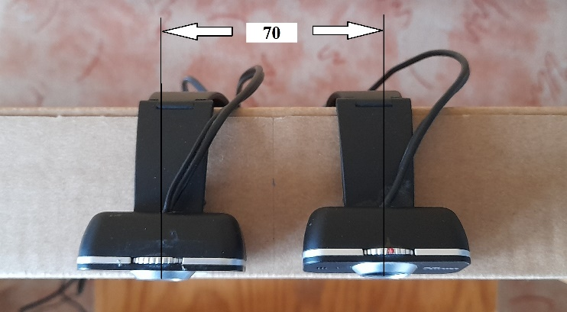

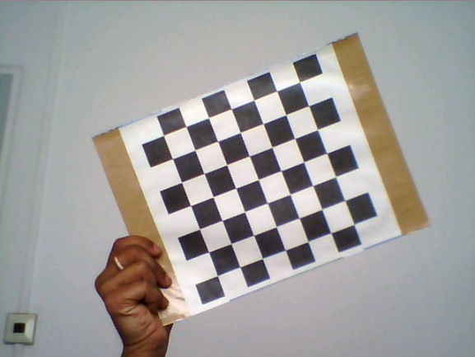

f

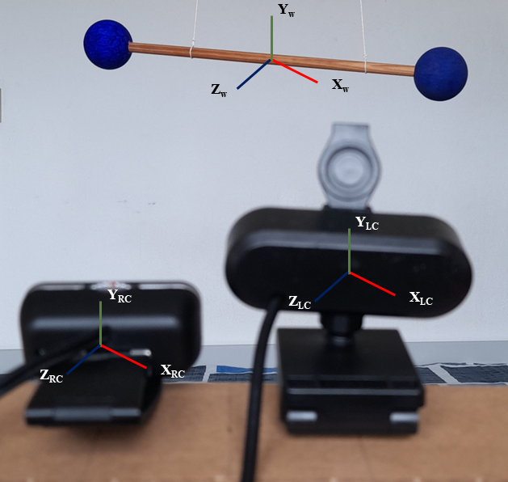

f

s

e

D

D

E

D

D

A

a